[Behavioural Brain Research 416 (2022) 113573](https://doi.org/10.1016/j.bbr.2021.113573)

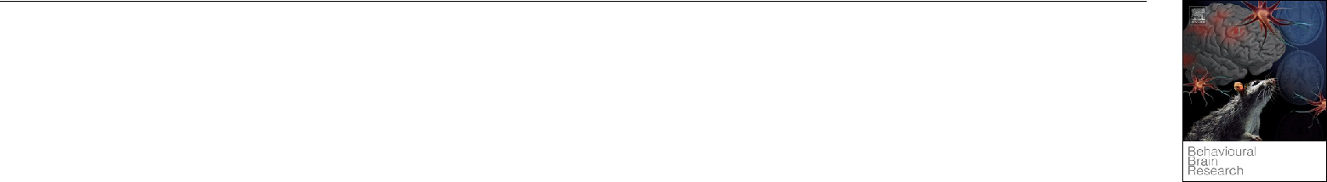

Contents lists available at [ScienceDirect](www.sciencedirect.com/science/journal/01664328)



Behavioural Brain Research

journal homepage: [www.elsevier.com/locate/bbr](https://www.elsevier.com/locate/bbr)

Research report



Activation of CB1 pathway in the perirhinal cortex is necessary but not sufficient for destabilization of contextual fear memory in rats

Che Jiang *, 1, Xiaona Wu 1, Jiajia Wang , Chunyong Li , Gaoquan Luo

*Department of Neurosurgery, General Hospital of Southern Theatre Command, Guangzhou, China*

A R T I C L E I N F O

*Keywords:*

Perirhinal cortex

Destabilization

Reconsolidation

Contextual fear conditioning

A B S T R A C T

According to the reconsolidation theory, memories can be modified through the destabilization-reconsolidation process. The rodent perirhinal cortex (PER; Brodmann areas 35 and 36) critically participates in the process of fear conditioning. Previous studies showed that some of the parahippocampal regions are critical for contextual fear memory reconsolidation. In our research, through a three-day paradigm of CFC, we showed that protein synthesis in PER of rats is required for memory reconsolidation, and activation of CB1 pathway is necessary but not sufficient in inducing memory destabilization. This result underlines parahippocampal regions in destabili-zation and reconsolidation process of fear memory besides amygdala and hippocampus.

**1. Introduction**

According to the reconsolidation theory, consolidated memory can be destabilized (return to a transient labile state susceptible to change) upon retrieval, and then be re-stabilized by reconsolidation. The destabilization-reconsolidation process provides an opportunity to modify maladaptive memories through behavioral or pharmacological interventions [1].

The rodent perirhinal cortex (PER; Brodmann areas 35 and 36) is homolog to that in primates. It has extensive connections with neocortex, subcortical structures, and hippo-parahippocampal struc-tures, contributing to the process of perception, learning and memory [2]. Besides its role in object recognition memory, which is more extensively studied, PER also critically participates in the process of fear conditioning [3–6]. Specifically, PER may have two functions termed as “stimulus unitization” and “transient memory” [7]. Additionally, in contextual fear conditioning (CFC), PER is suggested to play a role in storing memory or long-lasting consolidation and retrieval of memory after initial fear acquisition [8].

Recently, researchers showed that the lateral neocortex, which in-cludes the temporal association cortex, the auditory areas and PER, is critical for contextual fear memory reconsolidation [9]. Another study found that the entorhinal cortex, which is functionally connected with PER, contributes to the contextual fear memory reconsolidation [10].

The endocannabinoid (eCB) system is implicated in various

physiological processes, including the modulation of memory [11] and fear [12,13]. In the central nervous system, CB1 receptors are ubiquitous in the affective memory neural circuitry [11,14], and it is the main target of eCBs [15]. Previous studies showed that in CFC, destabilization of a contextual fear memory requires activation of CB1 receptors [16], and more importantly, it can be potentiated by promoting CB1 pathway in hippocampus or systemically, under behavioral conditions that by themselves do not result in destabilization [17].

Thus, we hypothesized that PER may play a crucial role in the destabilization-reconsolidation process of contextual fear memory in rats, and the eCB system may be a potential mechanism in destabiliza-tion. In this research, through a three-day paradigm of CFC, we showed that protein synthesis in PER is required for memory reconsolidation, and the activation of CB1 pathway is necessary but may not be sufficient to induce memory destabilization. Previous studies have shown that some key molecular pathways in amygdala [18] and hippocampus [17] are sufficient to induce destabilization. Whether this is the case with PER or PER is just a necessary condition deserves further study.

**2. Materials and methods**

*2.1. Subjects*

The procedures were approved by the animal ethic committee of our hospital in compliance with the US National Institutes of Health Guide

* Correspondence to: 111 Liuhua Road, Guangzhou, Guangdong, China.

*E-mail address:* [jc1987510@126.com](mailto:jc1987510@126.com)(C.Jiang).



1. Che Jiang and Xiaona Wu contributed equally to this work and should be considered co-first authors.

<https://doi.org/10.1016/j.bbr.2021.113573>

Received 3 June 2021; Received in revised form 23 August 2021; Accepted 29 August 2021

Available online 7 September 2021

0166-4328/© 2021 Elsevier B.V. All rights reserved.

*C. Jiang et al.*

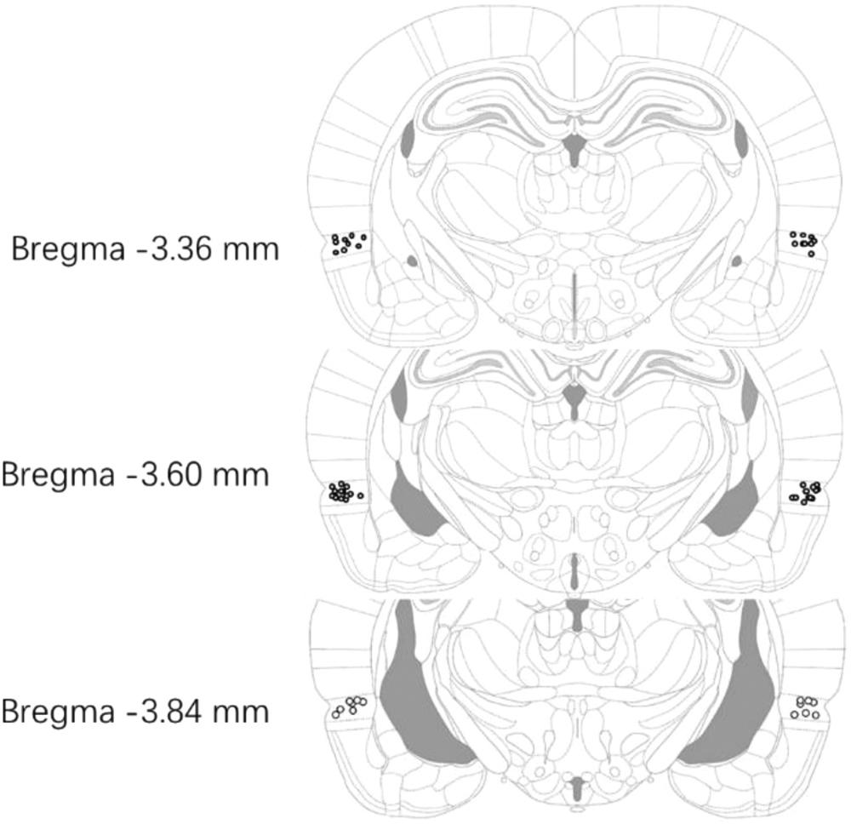

**Fig. 1.** Cannula placements in PER. Schematic of the infusion tip placementsfrom a representative group of rats (Experiment 1).

Brain section illustrations modified from Paxinos and Watson [19].

for the Care and Use of Laboratory Animals. Male Sprague-Dawley rats (280–320 g) were purchased from the Experimental Animal Center of our hospital. They were singly housed on a 12-hr light (day)/dark (night) schedule at 23 ℃ with free access to food and water. All behavioral experiments were performed between 09:00 a.m. and 15: 00 p.m.

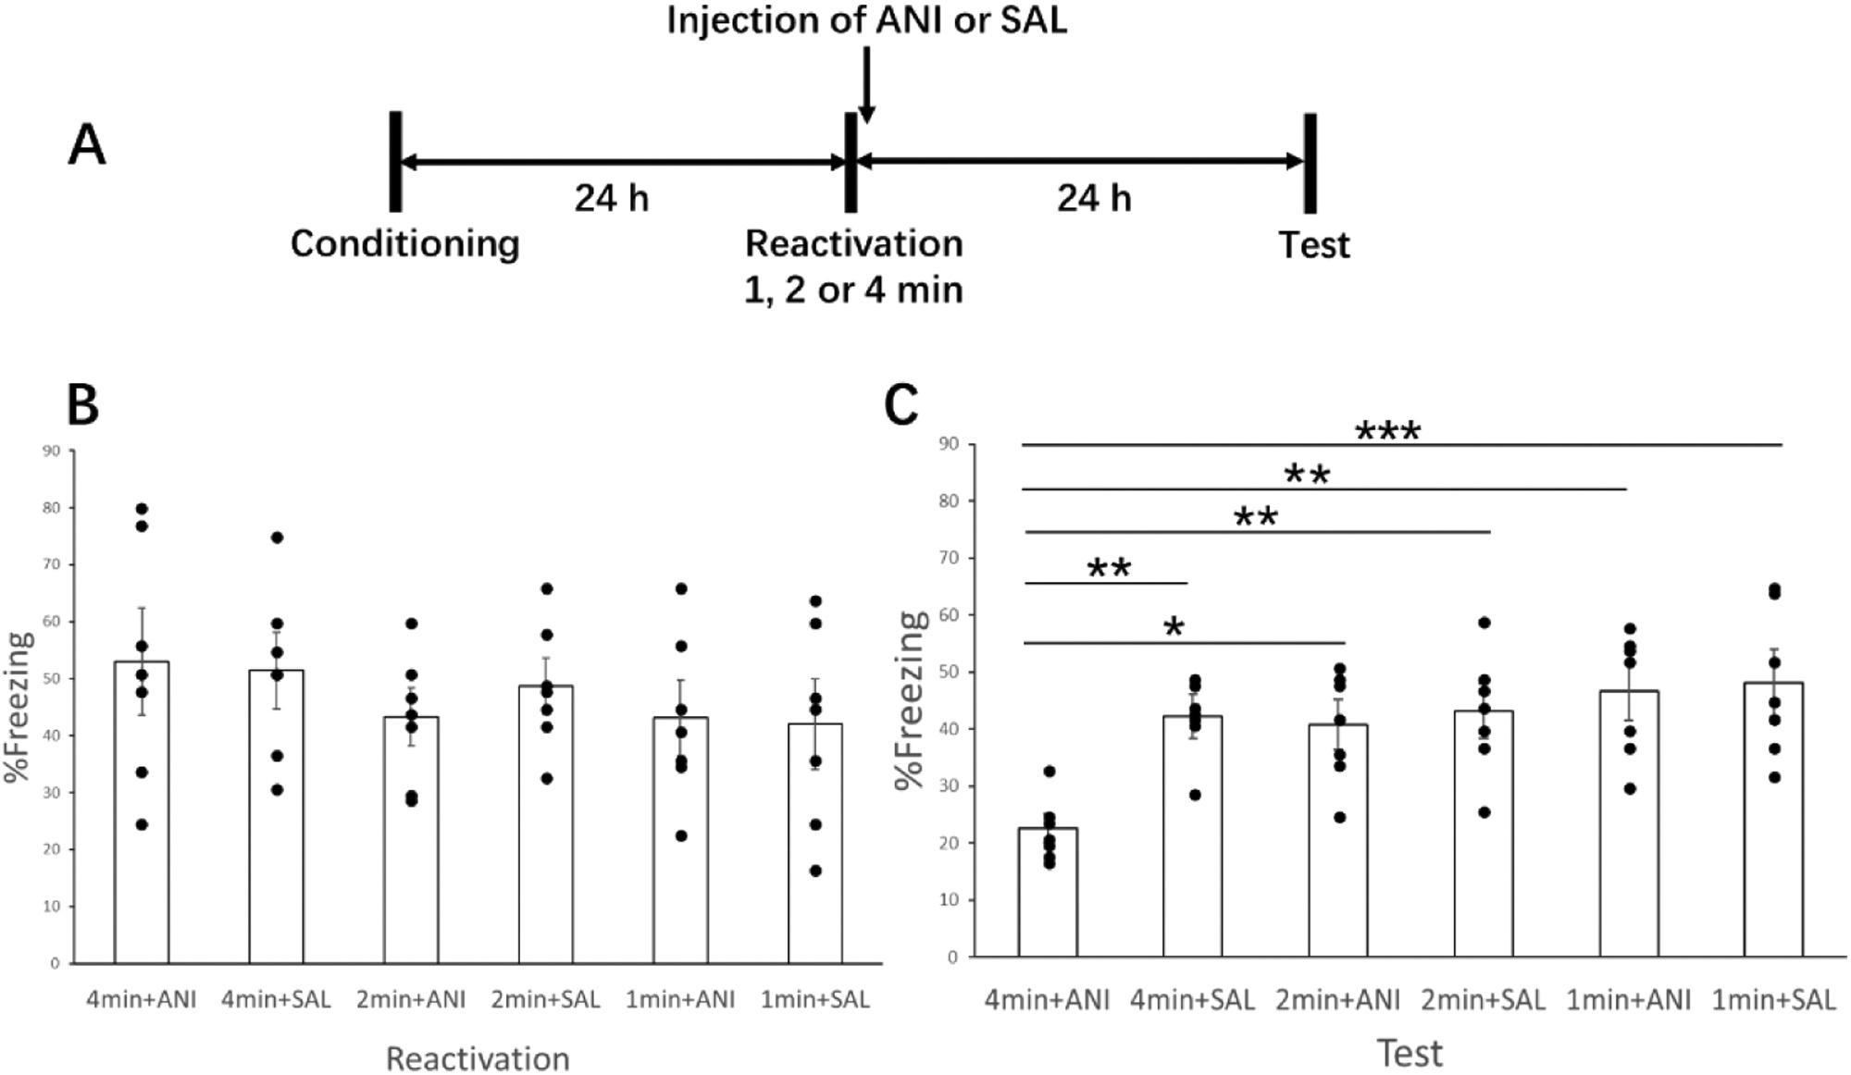

*Behavioural Brain Research 416 (2022) 113573*

*2.2. Surgery*

Rats were anaesthetized with sodium pentobarbital (50 mg/kg, i.p) and placed in a stereotaxic apparatus (Yuyan Instruments, Shanghai, China). An incision was made in the scalp and the connective tissue was retracted. Two stainless steel guide cannulas (OD: 0.56 mm) were implanted bilaterally in PER [coordinates: anteroposterior (AP), 3.6 mm from bregma; mediolateral (ML), ±6.5 mm from midline; dorso-ventral (DV), 6.3 mm from skull surface], with the incisor bar located 3.3 mm below the interaural line, according to the atlas of Paxinos and Watson [19]. The cannulas were secured with two anchoring screws affixed to the skull with dental cement. Stylets extending 1.0 mm beyond the guide cannulas, were inserted into the guides and remained except during infusions. Following surgery, the skin was sutured, and animals recovered with heat for 2 h before returning to their home cages. Behavioral protocols started after a 7d recovery period. During this re-covery period, the rats were handled daily for 1 min to habituate them to the infusion procedure and examine healing.

*2.3. Apparatus*

Contextual fear conditioning was conducted in an automated rodent fear conditioning system (Xinruan Informatlon Technology, China). The conditioning chamber consisted of an illuminated Plexiglas box (30 cm long × 30 cm wide × 60 cm high with opaque walls, the floor consisted of 18 parallel stainless-steel bars connected to a precision-regulated shocker). The chamber was encased in a sound-attenuated box equip-ped with a video camera on the ceiling used to record and quantify freezing behavior automatically.

*2.4. Drugs and administration*

Anisomycin (ANI; Target Molecules, USA) was solubilized fresh

**Fig. 2.** (A) Experimental design. Twenty-two hours after CFC, animals were re-exposed to the training context for 1, 2 or 4 min without shock. ANI or SAL wereinjected to bilateral PER immediately after the reactivation session. Bars are mean ± standard error of the mean (SEM) of percentage time spent freezing during reactivation (B) and test (C). Individual data is shown by black dot. The asterisks denote a significant statistical difference between the 4 min+ANI group and the rest groups. \**P* *<* 0.05, \*\**P* *<* 0.01, \*\*\**P* *<* 0.001.

2

*C. Jiang et al.*

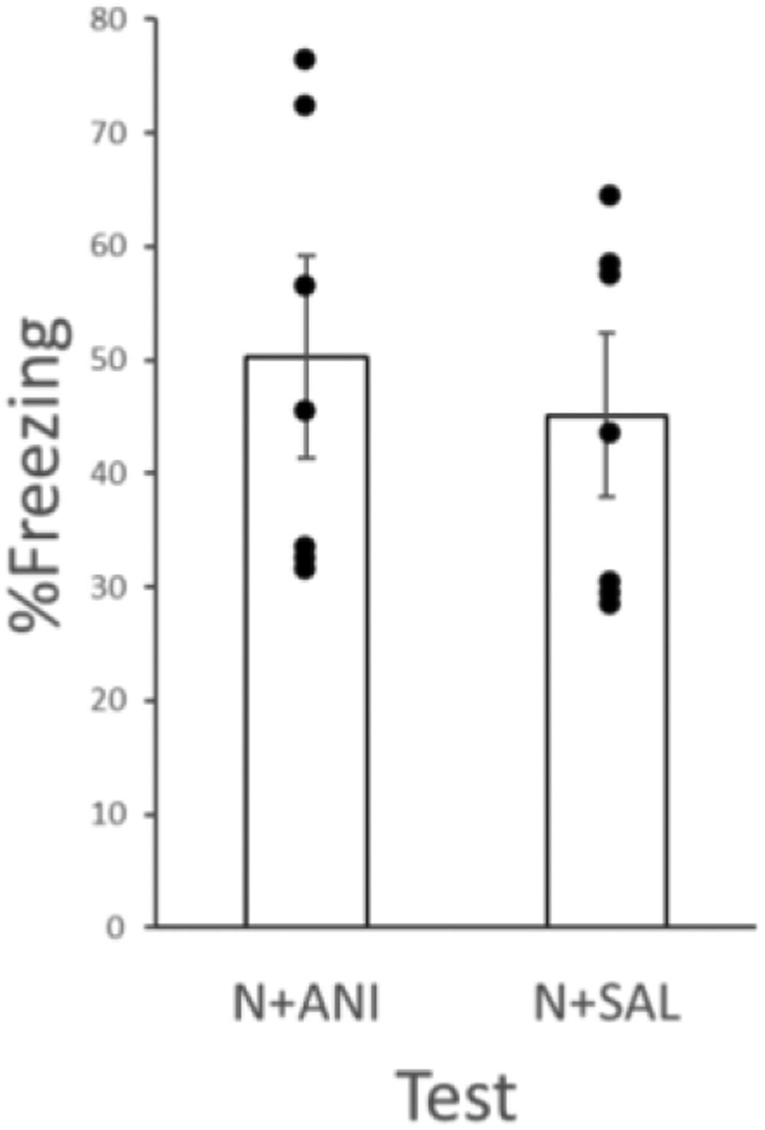

**Fig. 3.** Twenty-two hours after CFC, animals were injected with ANI or SALwithout being re-exposed to the training context. Twenty-two hours after in-jection, animals were tested. Bars are mean ± standard error of the mean (SEM) of percentage time spent freezing during test. Individual data is shown by black dot. No significant difference of freezing was found between the two groups.

before every behavior experiment at a concentration of 125 μg/μl in 1 M HCl and adjusted to pH 7.4 using 1 M NaOH [20]. This dose of aniso-mycin has previously been shown to disrupt memory reconsolidation [21].

CB1 antagonist, SR141716A (Axon, NL), was dissolved in a vehicle solution containing 3 drops (~100 μl) of Tween 80 in 2.5 mL of 7.5% dimethylsulfoxide in PBS to a concentration of 8 μg/μl [22].

CB1 receptor agonist, ACEA (Arachidonyl-2-chloroethylamide; ENZO, USA), was dissolved in sterile PBS with 0.1% DMSO to a con-centration of 5 pg/μl [17].

For microinfusion, stylets were removed and infusion cannulas (OD:0.36 mm), cut to extend 1 mm beyond the tip of the guide cannulas, were inserted. Bilateral infusions were conducted simultaneously using two 1.0 μl Hamilton syringes connected to the infusion cannulas with propylene tubing. The syringes were driven by a syringe pump. During 2 min, 1.0 μl/side of either drugs or an equivalent amount of saline (SAL) was injected. The displacement of an air bubble inside the polyethylene was used to monitor drug flow. The infusion cannulas were left in place for an additional 1 min to maximize diffusion and to prevent backflow of drug into the cannulas.

*2.5. Behavioral procedures*

Conditioning: rats were individually placed in the conditioning chamber, after 180 s acclimation received 2 unsignaled footshocks (1.0

*Behavioural Brain Research 416 (2022) 113573*

A, 2.0 s duration and 30 s intershock interval), and were kept in the chamber for an additional 30 s (post-shock period).

Reactivation: one day after training, rats were returned to the training context for 1,2 or 4 min without shock delivery in different experiments. Injections took place 15 min before (SR141716A or ACEA or SAL) and immediately after (ANI or SAL) the reactivation session. Animals in the no reactivation group were not re-exposed to the training context, but only received infusions and were returned to their home cages.

According to previous studies, re-exposure duration that could stably destabilize CFC fear memory ranges from 3 to 5 min across different regions of drug administration (e.g. amygdala [18,22–25], hippocampus [22], and systemically [26,27]), while 1 min’s re-exposure duration could not destabilize fear memory [28]. When re-exposure period is 1.5 or 2 min, there were contrary results as whether memory could be destabilized [10,29,30] or not [17,25], which possibly due to different protocols applied. So, in our study, we choose 1, 2 or 4 min’ re-exposure duration for reactivation.

Test: one day after the reactivation session, animals were reintro-duced into the training context for 5 min without shock delivery. All test sessions were video-recorded and automatically quantified for freezing behavior using video tracking software (Xinruan Informatlon Technol-ogy, China).

*2.6. Histology*

After behavioral testing, rats were anaesthetized by intraperitoneal injection of an overdose of sodium pentobarbital and transcardially perfused with physiological saline, followed by 4% neutral buffered formalin. Brains were removed from the skulls, postfixed with 4% paraformaldehyde at a low temperature for at least 24 h. Brains were coronally paraffin sectioned at a thickness of 40 µm. Brain sections were mounted on gelatine-coated glass slides and stained with hematoxylin-eosin to evaluate the cannula placements.

*2.7. Statistical analyses*

The results were expressed as the means ± SEM of freezing per-centage, and data were analyzed through ANOVAs or unpaired two-tailed *t*-tests. Levene’s test was used to evaluate variance homogenei-ty. For factorial ANOVAs, the factors analyzed were: Reactivation time (1 min vs 4 min), Pretreatment (SR141716A vs SAL; ACEA vs SAL) and Treatment (ANI vs SAL). For one-way ANOVAs，post hoc analysis of Tukey test (homogeneity of variance) or Dunnett’s T3 test (heteroge-neity of variance) was used. Effect size estimates were analyzed by η2*p* (ANOVAs). Statistical analysis was performed by Statistical Package for the Social Sciences (version 19.0 for Windows; SPSS, Chicago, IL, USA), and a *P* value of *<* 0.05 was considered significant.

**3. Results**

*3.1. Histology*

Bilateral guide cannula placements were confirmed, and only rats with infusion tips terminating in PRh were included in the analyses. Each group finally contains 7 rats with proper guide placements. The infusion tips ended at the border between areas 35 and 36, represented by the rhinal sulcus [31]. Placements were located between 3.36- and 3.84-mm posterior to bregma (Fig. 1).

*3.2. PER permits reconsolidation of fear memory*

In the first experiment, we aimed to study whether PER participates in fear memory reconsolidation. Experimental design and results are shown in Fig. 2. One-way ANOVAs (Tukey test) showed no significant difference between six groups during the reactivation session (*P* *>* 0.05

3

*C. Jiang et al.* *Behavioural Brain Research 416 (2022) 113573*

**Fig. 4.** (A) Experimental design. Twenty-twohours after CFC, animals were re-exposed to the training context for 4 min without shock. Injections took place 15 min before (SR141716A or SAL) and immediately after (ANI or SAL) the reactivation session. Bars are mean ± standard error of the mean (SEM) of percentage time spent freezing during reac-tivation (B) and test (C). Individual data is shown by black dot. The asterisks denote a significant statistical difference between the SAL+ANI group and the rest groups. \**P* *<* 0.01.

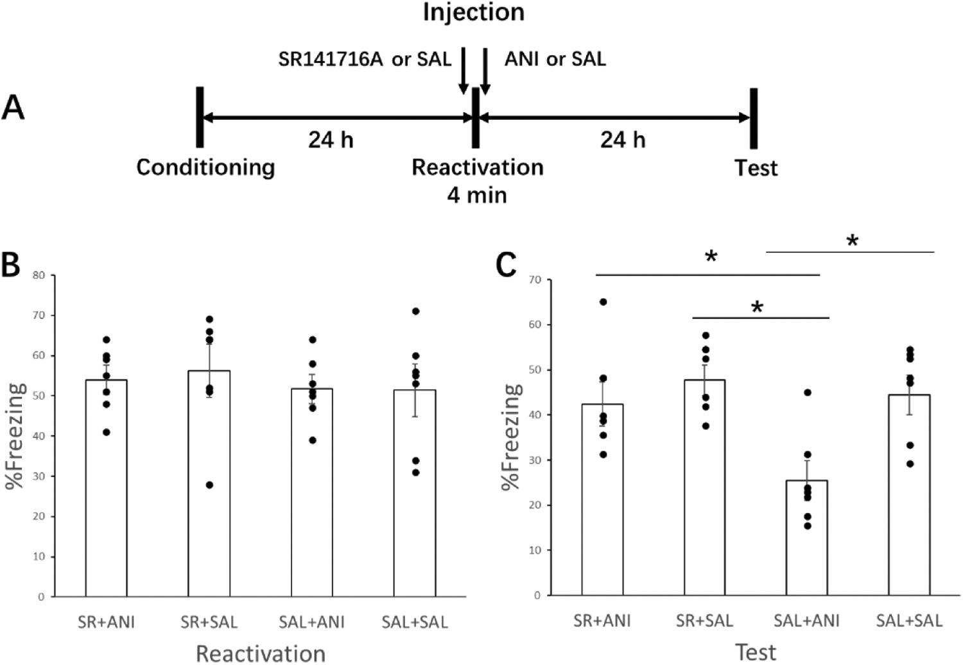

in all cases). A factorial ANOVA (drug × reactivation duration) analysis on the data of the test session revealed a significant effect of reactivation

duration [F (1,35) = 7.94, *P* = 0.001, η2*p* = 0.31], a significant effect of drug[F(1,35) = 6.44, *P* = 0.02, η2*p* = 0.16], and a significant effect of drug × reactivation interaction [F(1,35) = 4.00, *P* = 0.03, η2 *p* = 0.19]. One-way ANOVAs (Tukey test) showed that the 4 min + ANI group was

the only one expressing less fear at test session compared with the

remaining five (*P* = 0.006, =0.013, =0.004, =0.001, *<*0.001 vs

4 min+SAL, 2 min+ANI, 2 min+SAL, 1 min+ANI, 1 min+SAL,

respectively).

To ensure that the effects of anisomycin infusion were reactivation dependent, we conducted a further study including two no reactivation groups (N + ANI and N + SAL) (Fig. 3). Rats in this group received anisomycin or SAL infusion but without re-exposure on the second day. No significant difference of freezing was found between the two groups (*t* = 0.55, *P* = 0.59).

Our experiments showed that injection of ANI only affects fear memory when re-exposure duration lasts for 4 min, and the effects of anisomycin are reactivation dependent and not having non-specific ef-fects on memory storage. This result indicated when fear memory is destabilized, PER plays a role in permitting memory reconsolidation.

*3.3. CB1 antagonist in PER inhibits destabilization of fear memory*

Previous studies indicated that memory destabilization and recon-solidation involve the same brain area [32]. In the second experiment, we aimed to study whether PER, specifically through the CB1 pathway, also plays a role in fear memory destabilization. Experimental design is shown in Fig. 4. One-way ANOVAs (Tukey test) showed no significant difference between four groups during the reactivation session (*P* *>* 0.05 in all cases). At the test session, a factorial ANOVA (pre-treatment×-treatment) analysis revealed a significant effect of SR141716A [*F*(1,

24)= 8.62, *P* = 0.007, *η*2*p* = 0.26] and ANI [*F*(1,24)= 11.44, *P* = 0.002, *η*2*p* =0.32], but not SR141716A×ANI interaction [*F*(1,24)=4.02, *P* =0.056, *η*2*p* =0.14]. One-way ANOVAs (Tukey test) showed that the

SAL+ANI group was the only one expressing less fear at test session compared with the remaining three (*P* = 0.009, 0.001, 0.004 vs SR + ANI, SR + SAL, SAL + SAL, respectively).

To ensure that the effects of SR141716A + anisomycin infusion were

reactivation dependent, we conducted a further study including two no reactivation groups (N + SR + ANI and N + SAL + ANI) (Fig. 5). Rats in these groups received SR141716A or SAL infusion, and then received anisomycin infusion but without re-exposure on the second day. No significant difference of freezing was found between the two groups (*t* = 0.26, *P* = 0.80). Thus, our experiment showed that injection of SR141716A antagonized the effect of ANI, and this effect was reac-tivation dependent. This result indicated that blocking of CB1 pathway in PER inhibits destabilization of fear memory.

*3.4. Activation of CB1 pathway may not be sufficient to induce destabilization of fear memory*

The prior experiments showed that the activation of CB1 pathway in PER is a necessary condition for memory destabilization. Then we tested whether it is a sufficient condition, which means that activation of CB1 pathway through injection of CB1 receptor agonist (ACEA) can induce memory destabilization when reactivation itself is not enough to induce destabilization. Experimental design is shown in Fig. 6. One-way ANOVAs did not reveal a significant difference between any two of the four groups (ACEA + ANI, ACEA + SAL, SAL + ANI, and SAL + SAL group) at reactivation (*P* *>* 0.05 in all cases of) or test session (*P* *>* 0.05 in all cases).

Next, we conducted another experiment (Fig. 7). The procedure was the same as in the prior expeiment, except the reactivation session was 2 min. One-way ANOVAs did not reveal a significant difference between any two of the four groups (ACEA + ANI, ACEA + SAL, SAL + ANI, and SAL + SAL group) at reactivation (*P* *>* 0.05 in all cases) or test session (*P* *>* 0.05 in all cases).

Thus, our experiments indicated that activation of CB1 pathway in PER is not sufficient to induce destabilization of fear memory at least at this dose of ACEA injected.

**4. Discussion**

It is believed that consolidated memory is still dynamic and can be modified. According the reconsolidation theory, memory becomes vulnerable by some way of retrieval. After being reactivated and destabilized, the memory undergoes reconsolidation, during which

4

*C. Jiang et al.*

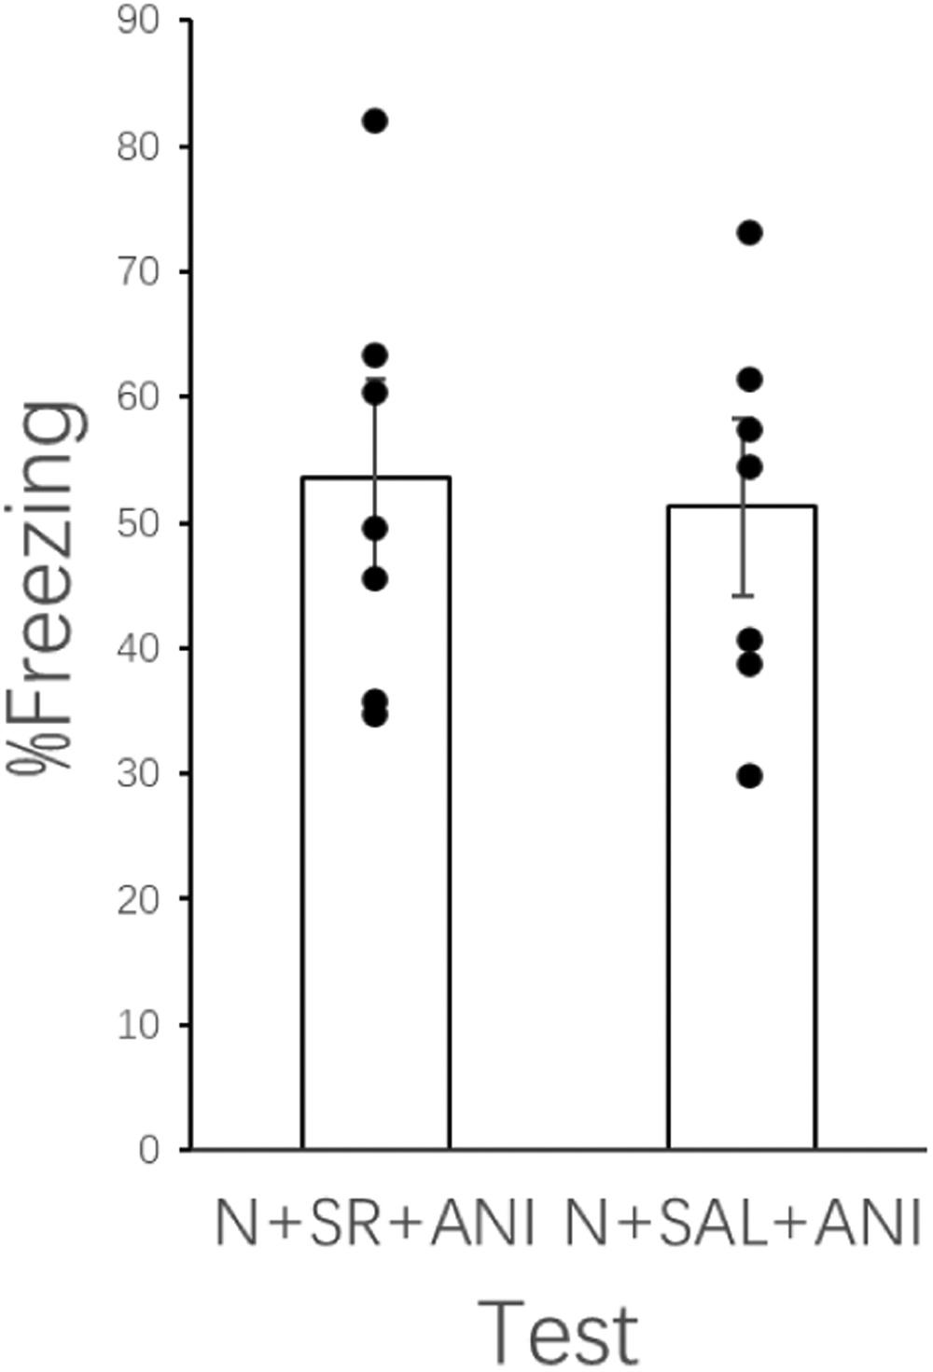

**Fig. 5.** Twenty-two hours after CFC, animals were injected with drugs withoutbeing re-exposed to the training context. Bars are mean ± standard error of the mean (SEM) of percentage time spent freezing during test. Individual data is shown by black dot. No significant difference of freezing was found between the two groups.

period intervention through behaviors or drugs can strengthen or attenuate the memory. The destabilization-reconsolidation process permits the updating of memory, so it is important for individual sur-vival to adapt the changing environment [33].

Destabilization is the initial and key step in the destabilization-reconsolidation process, and it requires for some “boundary condi-tions”. How to stably trigger destabilization through retrieval for memories that varies from strong to weak, and from old to new, is of difficulty. Elucidating the underlying neural circuit and potential mo-lecular pathway may help for developing drugs that facilitate memory destabilization.

As for fear memory, contextual/cued fear conditioning is a commonly used animal model. Previous studies focused on the amyg-dala (in CFC and cued fear condition) and hippocampus (in CFC) in memory destabilization-reconsolidation process. It has been found that activation of CB1 receptors in hippocampus [16,22] and amygdala [22] are required for destabilization of reactivated contextual fear [16]. Furthermore, systemic and intra-dorsal hippocampus administration of CB1 receptor agonist, ACEA, restored contextual fear memory destabi-lization under behavioral conditions that, by themselves, did not result in destabilization [17].

In rodents’ BLA, transient exchange of AMPARs (cued fear) [34], CaMKII- proteasome pathway (CFC) [29], GluN2B expression (CFC/cued fear) [24,35], and CB1-receptor (CFC) [22] are required for fear memory destabilization. Moreover, both systemic [26] and

*Behavioural Brain Research 416 (2022) 113573*

intra-BLA administration of D-cycloserine (a partial agonist of the NMDA receptors) prior to reactivation restored memory destabilization in animal models that are resistant to destabilization [18,24]. PER is more extensively studied in spontaneous object recognition memory. Researchers found that cholinergic muscarinic receptor (mAChR) pathway in PER can bidirectionally regulate destabilization of object memories in rodents [36]. The facilitation effect on destabilization is mediated by stimulating the ubiquitin proteasome system (UPS) via inositol triphosphate receptor (IP3R)-mediated release of intracellular calcium stores in PER [37]. Recently, it has been found that GluN2B- and GluN2A-containing NMDA receptors in PER are also required for object memory destabilization and reconsolidation [38]. Our experiments indicated that the activation of CB1 receptors in PER is required for the destabilization of contextual fear memory, but it is not sufficient to trigger destabilization under behavioral conditions that by themselves do not result in destabilization. Whether there are some molecular pathways in PER sufficient for destabilization needs further study. Anyway, combined with these results, it is very likely that there are ‘superior’ (being both necessary and sufficient) and ‘inferior’ (being necessary but not sufficient) molecular pathways that regulate destabi-lization. Additionally, in different brain regions and in different behavioral paradigm, the ‘superior’ molecular pathways vary (e.g. NMDA receptors pathway in BLA in CFC, CB1 receptors pathway in hippocampus in CFC, and mAChR pathway in PER in object recognition memory [38]). The common downstream pathway of destabilization may be the proteolysis by UPS, and it is an interesting topic to find out whether there are ‘common superior pathways’ upstream.

In the procedure of contextual fear memory acquisition, context in-formation is processed by PER, postrhinal cortex, and entorhinal cortex, then sent to hippocampus, and finally sent to BLA. When the hippo-campus is damaged or inactivated, there is an "alternative" neural cir-cuit, which includes PER, postrhinal cortex, and entorhinal cortex, to support context representations and functions [39,40]. If these para-hippocampal regions are damaged, then fear memory could not be ac-quired [41,42]. Thus, the function of parahippocampal regions is a necessary condition, while that of hippocampus is not in fear memory acquisition.

Additionally, PER may have two specific functions in fear condi-tioning as proposed by Kent et al. [7] One is “stimulus unitization”, which refers to the ability to treat two or more separate items or stimulus elements as a single entity. In fact, in object recognition memory, PER critically supports the object-related representation like identity, nov-elty, and object + place conjunctions through the integration of their visual and conceptual features [43,44]. In fear conditioning, temporal discontinuous tone (in auditory fear conditioning) or complex contexts (in CFC) need to be integrated as a unitary representation by PER so as to be associated with shocks (US) [45]. On the contrary, when the tone is continuous, PER is not required [7]. Another function of PER entails a type of “transient memory”. In cued fear conditioning, where there is a temporal gap or trace interval between the CS offset and the US onset, PER is required to form a transient CS representation during the trace interval so that it can be associated with shocks (US) [7,46].

As for the role of parahippocampal region, two studies revealed that the functions of lateral neocortex (including temporal association cor-tex, auditory areas and PER) [9] and the entorhinal cortex [10] are necessary for contextual fear memory reconsolidation. However, to the best of our knowledge, no study focused on fear memory destabilization. Our results showed that protein synthesis in PER is required for fear memory reconsolidation, and CB1 pathway is necessary in memory destabilization. It put forth the possibility that just as the process of acquisition, destabilization of fear memory also requires a complex neural circuit, but not just confined to some key areas like amygdala and hippocampus. Due to the important function of parahippocampal region in processing information coming from the cortex, it is reasonable to hypothesize that this neural circuit may expand to involve some sensory cortex.

5

*C. Jiang et al.* *Behavioural Brain Research 416 (2022) 113573*

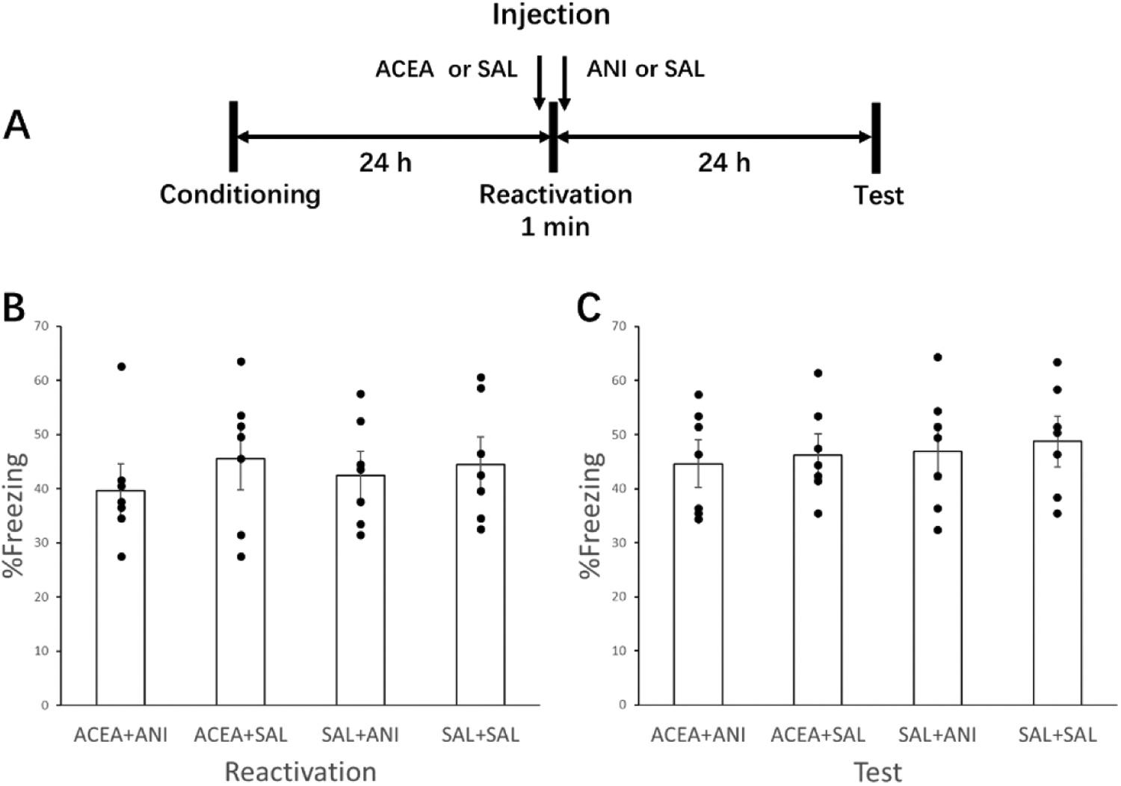

**Fig. 6.** (A) Experimental design. Twenty-two hours after CFC, animals were re-exposed to the training context for 1 min without shock. Injections took place 15 minbefore (ACEA or SAL) and immediately after (ANI or SAL) the reactivation session. Bars are mean ± standard error of the mean (SEM) of percentage time spent freezing during reactivation (B) and test (C). Individual data is shown by black dot. No significant difference of freezing was found between the four groups.

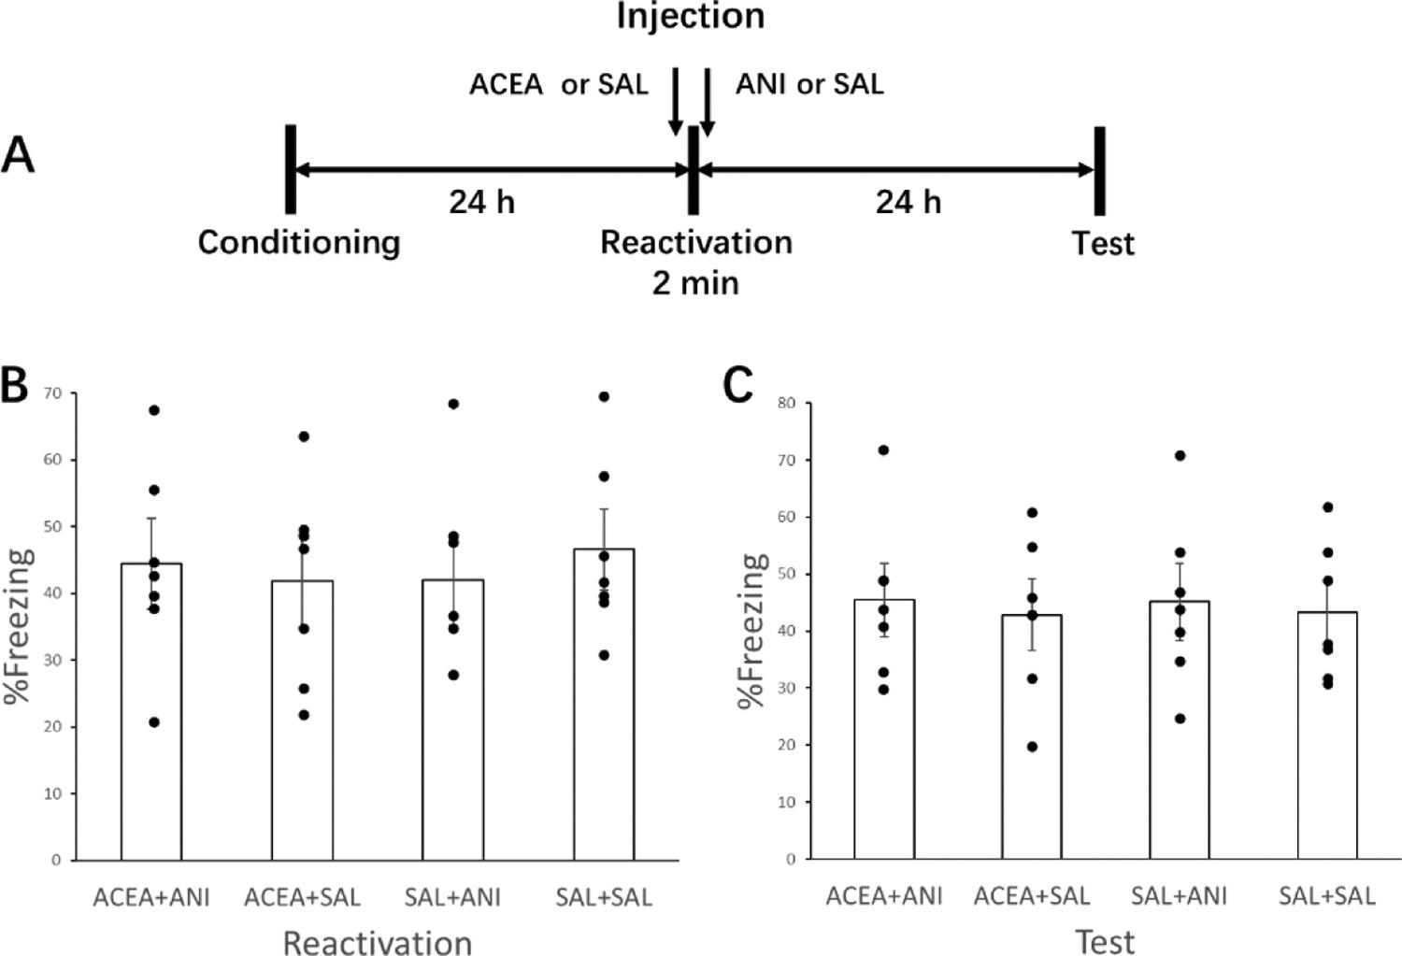

**Fig. 7.** (A) Experimental design. Twenty-two hours after CFC, animals were exposed to the training context for 2 min without shock. Injections took place 15 minbefore (ACEA or SAL) and immediately after (ANI or SAL) the reactivation session. Bars are mean ± standard error of the mean (SEM) of percentage time spent freezing during reactivation (B) and test (C). Individual data is shown by black dot. No significant difference of freezing was found between the four groups.

There are some limitations in our study. The dose of ACEA for in-jection into PER in our study was the same with the study by Lee et al., which showed that the destabilization of a contextual fear memory is potentiated by injection of ACEA [17]. Another study showed that in-jection of 0.01 fmol/side of ACEA in to dorsal hippocampus can hamper consolidation of object recognition memory. This dose is far lower than the dose used in our study. However, we cannot rule out the possibility that a higher dose of CB1 agonist may cause destabilization with a 1or

2 min reactivation duration. The second limitation is that the site of infusion is close to dorsolateral part of lateral amygdala (Paxinos and Watson) [19]. The diffusion of drugs may potentially affect the results. However, previous studies concerning reversible inhibition of rat’s PER had injection site ranged from 2.6 mm to 6.8 mm caudal in relation to bregma [8,38,47–56]. Two studies had injection site at 3.14 to

3.60 with respect to Bregma (lateral ± 6.5) [48,49], which is similar to the site in our study. Both studies used an injection volume of 1 μl/side.

6

*C. Jiang et al.*

Another study using 1 μl/side injection indicated that perirhinal in-fusions has limited spread into bordering brain areas [55].

**5. Conclusion**

In rats’ contextual fear memory, function of PER is required in both destabilization and reconsolidation process. Additionally, CB1 receptors pathway in PER is a necessary but may not be a sufficient condition for destabilization. The function of parahippocampal region in the destabilization-reconsolidation of contextual fear memory deserves more extensive study in the future.

**Funding**

This work was supported by the Military Medical Science and Technology Youth Cultivate Program [20QNPY078].

**CRediT authorship contribution statement**

**Che Jiang:** Conceptualization, Methodology, Writing–originaldraft, Visualization, Funding acquisition. **Xiaona Wu:** Validation, Methodology, Investigation, Visualization, Writing – review & editing. **Jiajia Wang:** Validation, Formal analysis, Supervision. **Chunyong Li:** Resources, Data curation. **Gaoquan Luo:** Visualization, Writing – re-view & editing.

**Acknowledgement**

None.

**References**

1. S.K. Kamboj, R.K. Das, Behavioral and pharmacological strategies for weakening [maladaptive reward memories: a new approach to treating a core disease](http://refhub.elsevier.com/S0166-4328(21)00461-7/sbref1) [mechanism in tobacco use disorder, JAMA Psychiatry 74 (3) (2017) 209–211](http://refhub.elsevier.com/S0166-4328(21)00461-7/sbref1).
2. [J.R. Ahn, I. Lee, Neural correlates of both perception and memory for objects in the](http://refhub.elsevier.com/S0166-4328(21)00461-7/sbref2) [rodent perirhinal cortex, Cereb. Cortex 27 (7) (2017) 3856–3868](http://refhub.elsevier.com/S0166-4328(21)00461-7/sbref2).
3. [C. Shi, M. Davis, Visual pathways involved in fear conditioning measured with](http://refhub.elsevier.com/S0166-4328(21)00461-7/sbref3) [fear-potentiated startle: behavioral and anatomic studies, J. Neurosci. 21 (24)](http://refhub.elsevier.com/S0166-4328(21)00461-7/sbref3) [(2001) 9844–9855](http://refhub.elsevier.com/S0166-4328(21)00461-7/sbref3).
4. [S.J. Bang, T.H. Brown, Perirhinal cortex supports acquired fear of auditory objects,](http://refhub.elsevier.com/S0166-4328(21)00461-7/sbref4) [Neurobiol. Learn. Mem. 92 (1) (2009) 53–62](http://refhub.elsevier.com/S0166-4328(21)00461-7/sbref4).
5. [T. Otto, G. Cousens, C. Herzog, Behavioral and neuropsychological foundations of](http://refhub.elsevier.com/S0166-4328(21)00461-7/sbref5) [olfactory fear conditioning, Behav. Brain Res. 110 (1–2) (2000) 119–128](http://refhub.elsevier.com/S0166-4328(21)00461-7/sbref5).
6. [R.D. Burwell, D.J. Bucci, M.R. Sanborn, M.J. Jutras, Perirhinal and postrhinal](http://refhub.elsevier.com/S0166-4328(21)00461-7/sbref6) [contributions to remote memory for context, J. Neurosci. 24 (49) (2004)](http://refhub.elsevier.com/S0166-4328(21)00461-7/sbref6)

[11023–11028](http://refhub.elsevier.com/S0166-4328(21)00461-7/sbref6).

1. [B.A. Kent, T.H. Brown, Dual functions of perirhinal cortex in fear conditioning,](http://refhub.elsevier.com/S0166-4328(21)00461-7/sbref7) [Hippocampus 22 (10) (2012) 2068–2079](http://refhub.elsevier.com/S0166-4328(21)00461-7/sbref7).
2. [L. Albrechet-Souza, K.G. Borelli, R.C. Almada, M.L. Brandao, Midazolam reduces](http://refhub.elsevier.com/S0166-4328(21)00461-7/sbref8) [the selective activation of the rhinal cortex by contextual fear stimuli, Behav. Brain](http://refhub.elsevier.com/S0166-4328(21)00461-7/sbref8) [Res. 216 (2) (2011) 631–638](http://refhub.elsevier.com/S0166-4328(21)00461-7/sbref8).
3. [V. de la Fuente, C. Medina, G. Falasco, L. Urrutia, A.V. Kravitz, F.J. Urbano,](http://refhub.elsevier.com/S0166-4328(21)00461-7/sbref9)
   1. [Vazquez,´ M.E. Pedreira, A. Romano, The lateral neocortex is critical for](http://refhub.elsevier.com/S0166-4328(21)00461-7/sbref9) [contextual fear memory reconsolidation, Sci. Rep. 9 (1) (2019) 12157](http://refhub.elsevier.com/S0166-4328(21)00461-7/sbref9).
4. [E. Baldi, C. Bucherelli, Entorhinal cortex contribution to contextual fear](http://refhub.elsevier.com/S0166-4328(21)00461-7/sbref10) [conditioning extinction and reconsolidation in rats, Neurobiol. Learn. Mem. 110](http://refhub.elsevier.com/S0166-4328(21)00461-7/sbref10) [(2014) 64–71](http://refhub.elsevier.com/S0166-4328(21)00461-7/sbref10).
5. [D. Piomelli, The molecular logic of endocannabinoid signalling, Nat. Rev.](http://refhub.elsevier.com/S0166-4328(21)00461-7/sbref11) [Neurosci. 4 (2003) 873–884](http://refhub.elsevier.com/S0166-4328(21)00461-7/sbref11).
6. [B. Lutz, The endocannabinoid system and extinction learning, Mol. Neurobiol. 36](http://refhub.elsevier.com/S0166-4328(21)00461-7/sbref12) [(2007) 92–101](http://refhub.elsevier.com/S0166-4328(21)00461-7/sbref12).
7. [C.J. Riebe, C.T. Wotjak, Endocannabinoids and stress, Stress 14 (2011) 384–397](http://refhub.elsevier.com/S0166-4328(21)00461-7/sbref13).
8. [F.V. Gouveia, D.C. Gidyk, P. Giacobbe, E. Ng, Y. Meng, B. Davidson, A. Abrahao,](http://refhub.elsevier.com/S0166-4328(21)00461-7/sbref14)
   1. [Lipsman, C. Hamani, Neuromodulation strategies in post-traumatic stress](http://refhub.elsevier.com/S0166-4328(21)00461-7/sbref14) [disorder: from preclinical models to clinical applications, Brain Sci. 9 (2019) 45](http://refhub.elsevier.com/S0166-4328(21)00461-7/sbref14).
9. [M.P. Viveros, E.M. Marco, S.E. File, Endocannabinoid system and stress and](http://refhub.elsevier.com/S0166-4328(21)00461-7/sbref15) [anxiety responses, Pharmacol. Biochem. Behav. 81 (2005) 331–342](http://refhub.elsevier.com/S0166-4328(21)00461-7/sbref15).
10. [A. Suzuki, T. Mukawa, A. Tsukagoshi, P.W. Frankland, S. Kida, Activation of](http://refhub.elsevier.com/S0166-4328(21)00461-7/sbref16) [LVGCCs and CB1 receptors required for destabilization of reactivated contextual](http://refhub.elsevier.com/S0166-4328(21)00461-7/sbref16) [fear memories, Learn Mem. 15 (6) (2008) 426–433](http://refhub.elsevier.com/S0166-4328(21)00461-7/sbref16).
11. [J.L. Lee, C.R. Flavell, Inhibition and enhancement of contextual fear memory](http://refhub.elsevier.com/S0166-4328(21)00461-7/sbref17) [destabilization, Front. Behav. Neurosci. 8 (2014) 144](http://refhub.elsevier.com/S0166-4328(21)00461-7/sbref17).
12. [V. Ortiz, M. Giachero, P.J. Espejo, V.A. Molina, I.D. Martijena, The effect of](http://refhub.elsevier.com/S0166-4328(21)00461-7/sbref18) Midazolam and Propranolol on fear memory reconsolidation in ethanol-withdrawn

*Behavioural Brain Research 416 (2022) 113573*

rats: influence of d-cycloserine, Int. J. Neuropsychopharmacol. 18 (4) (2015) pyu082.

1. [G. Paxinos, C. Watson, The Rat Brain in Stereotaxic Coordinates, Academic Press,,](http://refhub.elsevier.com/S0166-4328(21)00461-7/sbref19) [SanDiego, CA, 2005](http://refhub.elsevier.com/S0166-4328(21)00461-7/sbref19).
2. [K. Nader, G.E. Schafe, J.E. Le Doux, Fear memories require protein synthesis in the](http://refhub.elsevier.com/S0166-4328(21)00461-7/sbref20) [amygdala for reconsolidation after retrieval, Nature 406 (2000) 722–726](http://refhub.elsevier.com/S0166-4328(21)00461-7/sbref20).
3. [M.C. Ben, K. Gamache, K. Nader, NMDA receptors are critical for unleashing](http://refhub.elsevier.com/S0166-4328(21)00461-7/sbref21) [consolidated auditory fear memories, Nat. Neurosci. 9 (2006) 1237–1239](http://refhub.elsevier.com/S0166-4328(21)00461-7/sbref21).
4. [J.L.C. Lee, F.E. Amorim, L.F. Cassini, O.B. Amaral, Different temporal windows for](http://refhub.elsevier.com/S0166-4328(21)00461-7/sbref22) [CB1 receptor involvement in contextual fear memory destabilisation in the](http://refhub.elsevier.com/S0166-4328(21)00461-7/sbref22) [amygdala and hippocampus, PLoS One 14 (1) (2019), 0205781](http://refhub.elsevier.com/S0166-4328(21)00461-7/sbref22).
5. [P.J. Espejo, V. Ortiz, I.D. Martijena, V.A. Molina, GABAergic signaling within the](http://refhub.elsevier.com/S0166-4328(21)00461-7/sbref23) [Basolateral Amygdala Complex modulates resistance to the labilization/](http://refhub.elsevier.com/S0166-4328(21)00461-7/sbref23) [reconsolidation process, Neurobiol. Learn. Mem. 144 (2017) 166–173](http://refhub.elsevier.com/S0166-4328(21)00461-7/sbref23).
6. [P.J. Espejo, V. Ortiz, I.D. Martijena, V.A. Molina, Stress-induced resistance to the](http://refhub.elsevier.com/S0166-4328(21)00461-7/sbref24) [fear memory labilization/reconsolidation process. Involvement of the basolateral](http://refhub.elsevier.com/S0166-4328(21)00461-7/sbref24) [amygdala complex, Neuropharmacology 109 (2016) 349–356](http://refhub.elsevier.com/S0166-4328(21)00461-7/sbref24).
7. [R.I.F. Monti, M. Giachero, J.M. Alfei, A.M. Bueno, G. Cuadra, V.A. Molina, An](http://refhub.elsevier.com/S0166-4328(21)00461-7/sbref25) [appetitive experience after fear memory destabilization attenuates fear retention:](http://refhub.elsevier.com/S0166-4328(21)00461-7/sbref25) [involvement GluN2B-NMDA receptors in the Basolateral Amygdala Complex,](http://refhub.elsevier.com/S0166-4328(21)00461-7/sbref25) [Learn. Mem. 23 (9) (2016) 465–478](http://refhub.elsevier.com/S0166-4328(21)00461-7/sbref25).
8. [S.G. Bustos, M. Giachero, H. Maldonado, V.A. Molina, Previous stress attenuates](http://refhub.elsevier.com/S0166-4328(21)00461-7/sbref26) [the susceptibility to Midazolam’s disruptive effect on fear memory reconsolidation:](http://refhub.elsevier.com/S0166-4328(21)00461-7/sbref26) [influence of pre-reactivation D-cycloserine administration,](http://refhub.elsevier.com/S0166-4328(21)00461-7/sbref26) [Neuropsychopharmacology 35 (5) (2010) 1097–1108](http://refhub.elsevier.com/S0166-4328(21)00461-7/sbref26).
9. [L. Gazarini, C.A.J. Stern, R.R. Piornedo, R.N. Takahashi, L.J. Bertoglio, PTSD-like](http://refhub.elsevier.com/S0166-4328(21)00461-7/sbref27) [memory generated through enhanced noradrenergic activity is mitigated by a dual](http://refhub.elsevier.com/S0166-4328(21)00461-7/sbref27) [step pharmacological intervention targeting its reconsolidation, Int. J.](http://refhub.elsevier.com/S0166-4328(21)00461-7/sbref27)

[Neuropsychopharmacol. 18 (1) (2014) pyu026](http://refhub.elsevier.com/S0166-4328(21)00461-7/sbref27).

1. [M.E. Pineyro,˜ R.I.F. Monti, J.M. Alfei, A.M. Bueno, G.P. Urcelay, Memory](http://refhub.elsevier.com/S0166-4328(21)00461-7/sbref28) [destabilization is critical for the success of the reactivation-extinction procedure,](http://refhub.elsevier.com/S0166-4328(21)00461-7/sbref28) [Learn. Mem. 21 (1) (2013) 46–54](http://refhub.elsevier.com/S0166-4328(21)00461-7/sbref28).
2. [T.J. Jarome, N.C. Ferrara, J.L. Kwapis, F.J. Helmstetter, CaMKII regulates](http://refhub.elsevier.com/S0166-4328(21)00461-7/sbref29) [proteasome phosphorylation and activity and promotes memory destabilization](http://refhub.elsevier.com/S0166-4328(21)00461-7/sbref29) [following retrieval, Neurobiol. Neurobiol. Learn. Mem. 128 (2016) 103–109](http://refhub.elsevier.com/S0166-4328(21)00461-7/sbref29).
3. [C.R. Flavell, D.J. Barber, J.L.C. Lee, Behavioural memory reconsolidation of food](http://refhub.elsevier.com/S0166-4328(21)00461-7/sbref30) [and fear memories, Nat. Commun. 2 (2011) 504](http://refhub.elsevier.com/S0166-4328(21)00461-7/sbref30).
4. [R.D. Burwell, Borders and cytoarchitecture of the perirhinal and postrhinal cortices](http://refhub.elsevier.com/S0166-4328(21)00461-7/sbref31) [in the rat, J. Comp. Neurol. 437 (2001) 17–41](http://refhub.elsevier.com/S0166-4328(21)00461-7/sbref31).
5. [S.H. Lee, C. Kwak, J. Shim, J.E. Kim, S.L. Choi, H.F. Kim, D.J. Jang, J.A. Lee, K. Lee,](http://refhub.elsevier.com/S0166-4328(21)00461-7/sbref32) [C.H. Lee, Y.D. Lee, M.C. Miniaci, C.H. Bailey, E.R. Kandel, B.K. Kaang, A cellular](http://refhub.elsevier.com/S0166-4328(21)00461-7/sbref32) [model of memory reconsolidation involves reactivation-induced destabilization](http://refhub.elsevier.com/S0166-4328(21)00461-7/sbref32) [and restabilization at the sensorimotor synapse in Aplysia, Proc. Natl. Acad. Sci.](http://refhub.elsevier.com/S0166-4328(21)00461-7/sbref32) [USA 109 (35) (2012) 14200–14205](http://refhub.elsevier.com/S0166-4328(21)00461-7/sbref32).
6. [D. Schiller, E.A. Phelps, Does reconsolidation occur in humans? Front. Behav.](http://refhub.elsevier.com/S0166-4328(21)00461-7/sbref33) [Neurosci. 5 (2011) 24](http://refhub.elsevier.com/S0166-4328(21)00461-7/sbref33).
7. [I. Hong, J. Kim, J. Kim, S. Lee, H.G. Ko, K. Nader, B.K. Kaang, R.W. Tsien, S. Choi,](http://refhub.elsevier.com/S0166-4328(21)00461-7/sbref34) [AMPA receptor exchange underlies transient memory destabilization on retrieval,](http://refhub.elsevier.com/S0166-4328(21)00461-7/sbref34) [Proc. Natl. Acad. Sci. USA 110 (20) (2013) 8218–8223](http://refhub.elsevier.com/S0166-4328(21)00461-7/sbref34).
8. [A.L. Milton, E. Merlo, P. Ratano, B.L. Gregory, J.K. Dumbreck, B.J. Everitt, Double](http://refhub.elsevier.com/S0166-4328(21)00461-7/sbref35) [dissociation of the requirement for GluN2B- and GluN2A-containing NMDA](http://refhub.elsevier.com/S0166-4328(21)00461-7/sbref35) [receptors in the destabilization and restabilization of a reconsolidating memory,](http://refhub.elsevier.com/S0166-4328(21)00461-7/sbref35)
   1. [Neurosci. 33 (3) (2013) 1109–1115](http://refhub.elsevier.com/S0166-4328(21)00461-7/sbref35).
9. [M.L. Stiver, D.L. Jacklin, K.A. Mitchnick, N. Vicic, J. Carlin, M. O’Hara, B.](http://refhub.elsevier.com/S0166-4328(21)00461-7/sbref36)
   1. [Winters, Cholinergic manipulations bidirectionally regulate object memory](http://refhub.elsevier.com/S0166-4328(21)00461-7/sbref36) [destabilization, Learn. Mem. 22 (4) (2015) 203–214](http://refhub.elsevier.com/S0166-4328(21)00461-7/sbref36).
10. [M.L. Stiver, J.M. Cloke, N. Nightingale, J. Rizos, W.S. Messer Jr., B.D. Winters,](http://refhub.elsevier.com/S0166-4328(21)00461-7/sbref37) [Linking muscarinic receptor activation to UPS-mediated object memory](http://refhub.elsevier.com/S0166-4328(21)00461-7/sbref37) [destabilization: implications for long-term memory modification and storage,](http://refhub.elsevier.com/S0166-4328(21)00461-7/sbref37) [Neurobiol. Learn. Mem. 145 (2017) 151–164](http://refhub.elsevier.com/S0166-4328(21)00461-7/sbref37).
11. [C.E. Wideman, J. Nguyen, S.D. Jeffries, B.D. Winters, Fluctuating NMDA receptor](http://refhub.elsevier.com/S0166-4328(21)00461-7/sbref38) [subunit levels in perirhinal cortex relate to their dynamic roles in object memory](http://refhub.elsevier.com/S0166-4328(21)00461-7/sbref38) [destabilization and reconsolidation, Int. J. Mol. Sci. 22 (1) (2020) 67](http://refhub.elsevier.com/S0166-4328(21)00461-7/sbref38).
12. [J.W. Rudy, Context representations, context functions, and the](http://refhub.elsevier.com/S0166-4328(21)00461-7/sbref39) [parahippocampal–hippocampal system, Learn. Mem. 16 (10) (2009) 573–585](http://refhub.elsevier.com/S0166-4328(21)00461-7/sbref39).
13. [S. Maren, M.S. Fanselow, Electrolytic lesions of the fimbria/fornix, dorsal](http://refhub.elsevier.com/S0166-4328(21)00461-7/sbref40) [hippocampus, or entorhinal cortex produce anterograde deficits in contextual fear](http://refhub.elsevier.com/S0166-4328(21)00461-7/sbref40) [conditioning in rats, Neurobiol. Learn. Mem. 67 (1997) 142–149](http://refhub.elsevier.com/S0166-4328(21)00461-7/sbref40).
14. [D.H. Lindquist, L.E. Jarrard, T.H. Brown, Perirhinal cortex supports delay fear](http://refhub.elsevier.com/S0166-4328(21)00461-7/sbref41) [conditioning to rat ultrasonic social signals, J. Neurosci. 24 (2004) 3610–3617](http://refhub.elsevier.com/S0166-4328(21)00461-7/sbref41).
15. [D.J. Bucci, M.P. Saddoris, R.D. Burwell, Contextual fear discrimination is impaired](http://refhub.elsevier.com/S0166-4328(21)00461-7/sbref42) [by damage to the postrhinal or perirhinal cortex, Behav. Neurosci. 116 (2002)](http://refhub.elsevier.com/S0166-4328(21)00461-7/sbref42) [479–488](http://refhub.elsevier.com/S0166-4328(21)00461-7/sbref42).
16. [C.B. Martin, D. Douglas, R.N. Newsome, L.L. Man, M.D. Barense, Integrative and](http://refhub.elsevier.com/S0166-4328(21)00461-7/sbref43) [distinctive coding of visual and conceptual object features in the ventral visual](http://refhub.elsevier.com/S0166-4328(21)00461-7/sbref43) [stream, Elife 7 (2018), e31873](http://refhub.elsevier.com/S0166-4328(21)00461-7/sbref43).
17. [S.S. Deshmukh, J.L. Johnson, J.J. Knierim, Perirhinal cortex represents nonspatial,](http://refhub.elsevier.com/S0166-4328(21)00461-7/sbref44) [but not spatial, information in rats foraging in the presence of objects: comparison](http://refhub.elsevier.com/S0166-4328(21)00461-7/sbref44) [with lateral entorhinal cortex, Hippocampus 22 (2012) 2045–2058](http://refhub.elsevier.com/S0166-4328(21)00461-7/sbref44).
18. [D.B. Kholodar-Smith, T.A. Allen, T.H. Brown, Fear conditioning to discontinuous](http://refhub.elsevier.com/S0166-4328(21)00461-7/sbref45) [auditory cues requires perirhinal cortical function, Behav. Neurosci. 122 (5) (2008)](http://refhub.elsevier.com/S0166-4328(21)00461-7/sbref45) [1178–1185](http://refhub.elsevier.com/S0166-4328(21)00461-7/sbref45).
19. [D.B. Kholodar-Smith, P. Boguszewski, T.H. Brown, Auditory trace fear conditioning](http://refhub.elsevier.com/S0166-4328(21)00461-7/sbref46) [requires perirhinal cortex, Neurobiol. Learn. Mem. 90 (3) (2008) 537–543](http://refhub.elsevier.com/S0166-4328(21)00461-7/sbref46).
20. [B. Schulz-Klaus, V. Lessmann, T. Endres, BDNF-dependent consolidation of fear](http://refhub.elsevier.com/S0166-4328(21)00461-7/sbref47) memories in the perirhinal cortex, Front Behav. Neurosci. 7 (2013) 205.

7

*C. Jiang et al.*

1. I. Balderas, C.J. Rodriguez-Ortiz, F. Bermudez-Rattoni, Retrieval and [reconsolidation of object recognition memory are independent processes in the](http://refhub.elsevier.com/S0166-4328(21)00461-7/sbref48) [perirhinal cortex, Neuroscience 253 (2013) 398–405](http://refhub.elsevier.com/S0166-4328(21)00461-7/sbref48).
2. [M. Santoyo-Zedillo, C.J. Rodriguez-Ortiz, G. Chavez-Marchetta, F. Bermudez-Rattoni, I. Balderas, Retrieval is not necessary to trigger reconsolidation of object](http://refhub.elsevier.com/S0166-4328(21)00461-7/sbref49) [recognition memory in the perirhinal cortex, Learn. Mem. 21 (9) (2014) 452–456](http://refhub.elsevier.com/S0166-4328(21)00461-7/sbref49).
3. [N.M. Holmes, S.L. Parkes, A.S. Killcross, R.F. Westbrook, The basolateral amygdala](http://refhub.elsevier.com/S0166-4328(21)00461-7/sbref50) [is critical for learning about neutral stimuli in the presence of danger, and the](http://refhub.elsevier.com/S0166-4328(21)00461-7/sbref50) [perirhinal cortex is critical in the absence of danger, J. Neurosci. 33 (32) (2013)](http://refhub.elsevier.com/S0166-4328(21)00461-7/sbref50) [13112–13125](http://refhub.elsevier.com/S0166-4328(21)00461-7/sbref50).
4. [F.S. Wong, R.F. Westbrook, N.M. Holmes, ‘Online’ integration of sensory and fear](http://refhub.elsevier.com/S0166-4328(21)00461-7/sbref51) [memories in the rat medial temporal lobe, Elife 8 (2019), e47085](http://refhub.elsevier.com/S0166-4328(21)00461-7/sbref51).
5. [N.M. Holmes, M. Raipuria, O.A. Qureshi, S. Killcross, F. Westbrook, Danger](http://refhub.elsevier.com/S0166-4328(21)00461-7/sbref52) [changes the way the mammalian brain stores information about innocuous events:](http://refhub.elsevier.com/S0166-4328(21)00461-7/sbref52) a study of sensory preconditioning in rats, eNeuro 5 (1) (2018).

*Behavioural Brain Research 416 (2022) 113573*

1. A.R. Hernandez, J.E. Reasor, L.M. Truckenbrod, K.N. Lubke, S.A. Johnson, J.
   1. [Bizon, A.P. Maurer, S.N. Burke, Medial prefrontal-perirhinal cortical](http://refhub.elsevier.com/S0166-4328(21)00461-7/sbref53) [communication is necessary for flexible response selection, Neurobiol. Learn Mem.](http://refhub.elsevier.com/S0166-4328(21)00461-7/sbref53) [137 (2017) 36–47](http://refhub.elsevier.com/S0166-4328(21)00461-7/sbref53).
2. [J.M. Kim, D.H. Kim, Y. Lee, S.J. Park, J.H. Ryu, Distinct roles of the hippocampus](http://refhub.elsevier.com/S0166-4328(21)00461-7/sbref54) [and perirhinal cortex in GABAA receptor blockade-induced enhancement of object](http://refhub.elsevier.com/S0166-4328(21)00461-7/sbref54) [recognition memory, Brain Res. 1552 (2014) 17–25](http://refhub.elsevier.com/S0166-4328(21)00461-7/sbref54).
3. [C.J. Tinsley, K.E. Narduzzo, M.W. Brown, E.C. Warburton, A role for the CAMKK](http://refhub.elsevier.com/S0166-4328(21)00461-7/sbref55) [pathway in visual object recognition memory, Hippocampus 22 (3) (2012)](http://refhub.elsevier.com/S0166-4328(21)00461-7/sbref55)

[466–476](http://refhub.elsevier.com/S0166-4328(21)00461-7/sbref55).

1. [K.A. Mitchnick, S.D. Creighton, J.M. Cloke, M. Wolter, O. Zaika, B. Christen, M.](http://refhub.elsevier.com/S0166-4328(21)00461-7/sbref56)
   1. [Tiggelen, B.E. Kalisch, B.D. Winters, Dissociable roles for histone](http://refhub.elsevier.com/S0166-4328(21)00461-7/sbref56) [acetyltransferases p300 and PCAF in hippocampus and perirhinal cortex-mediated](http://refhub.elsevier.com/S0166-4328(21)00461-7/sbref56) object memory, Genes Brain Behav. 15 (6) (2016) 542[–](http://refhub.elsevier.com/S0166-4328(21)00461-7/sbref56)557.

8